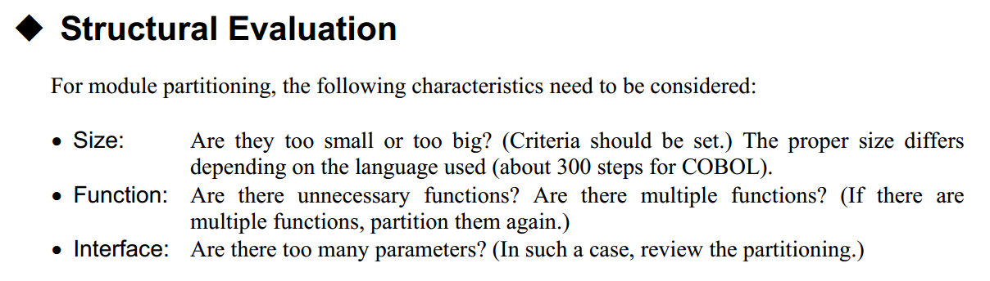

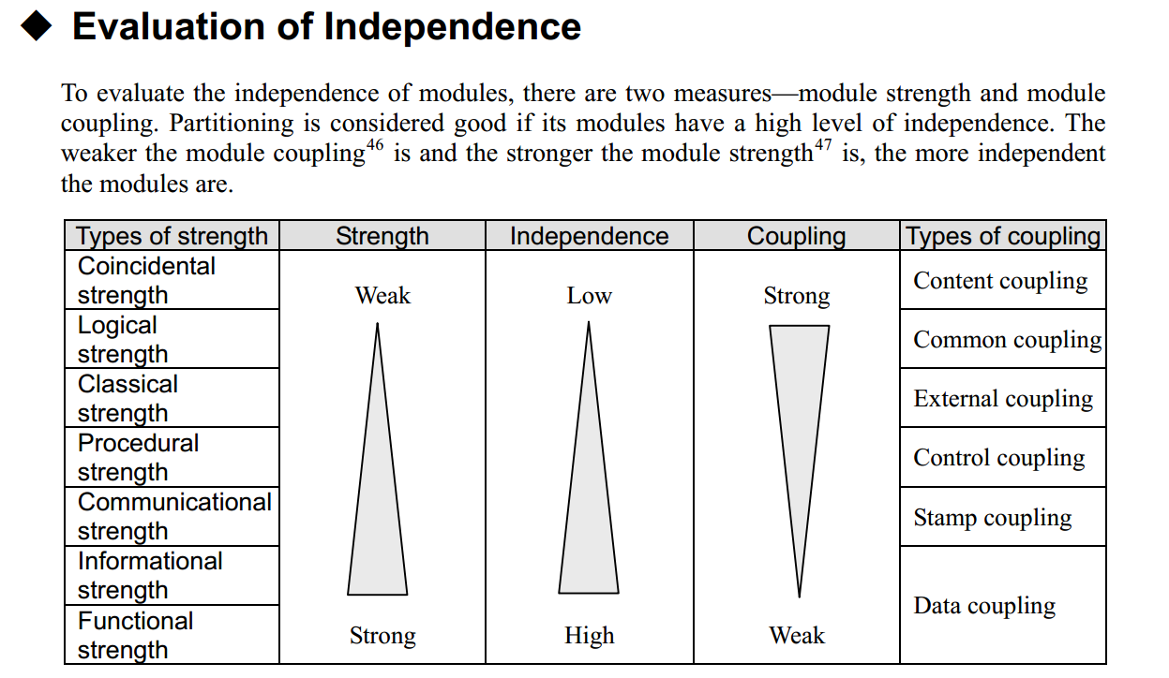

Module coupling: It is a measure of how closely modules are related to one another; the weaker the module coupling is the more independent they are.

Module strength: It is a measure of how closely the component elements within a module are related to one another; the stronger the module strength is; the more independent the modules are.

Functional strength and data coupling are the best.

